Term 3

After School Newsletter

2020

Happy new year to everyone, we have really enjoyed our first few weeks of the new year. Playing games, baking, creating valentines day crafts and having fun together.

Here’s what our children had to say

“I like colouring”– Skye Year 3.

“I enjoy the food -Timeo Year 4.

“I like creating and colouring” – Luka Year 1.

“ I enjoy making friends –Alice Year 3.

“I love that we have grapes” –Sienna Year 2.

“What I like about After School Club is everyone in After School Club.” – Alex Year 3

“I like that we are always supported.” – Shiloh Year 5

Opening times.

After School Club is open every day from 3:15 until 5:30.

Booking

Please remember if you would like your child to come to After School Club always book with the office to ensure there is a place, thank you.

Here’s some of the fun things we’ve been up to this term.

.

Making jam tarts

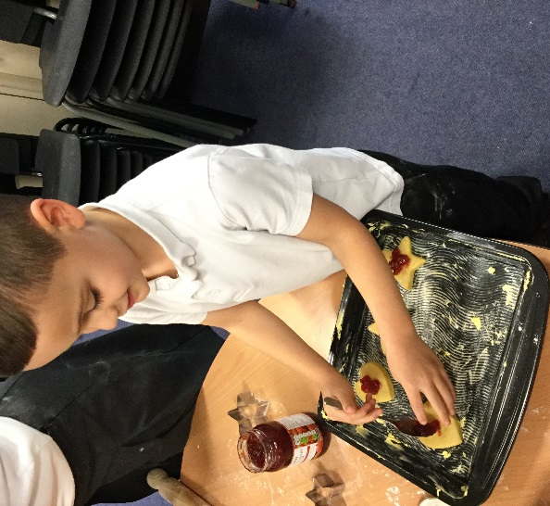

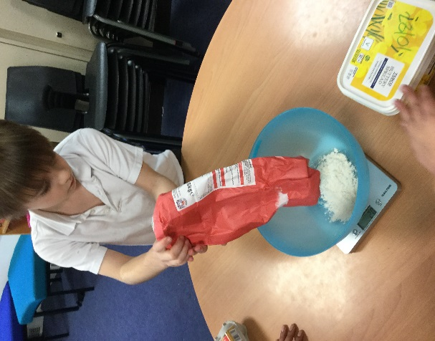

Creating Valentines day cards

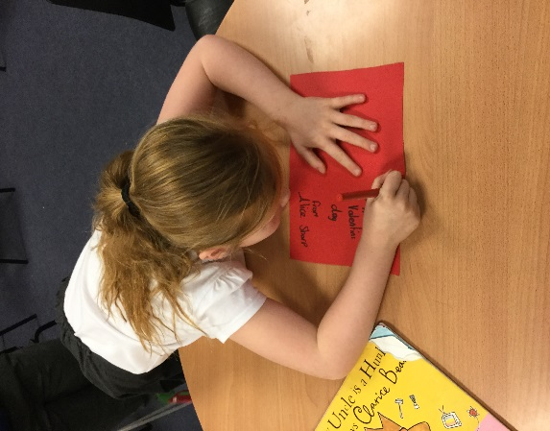

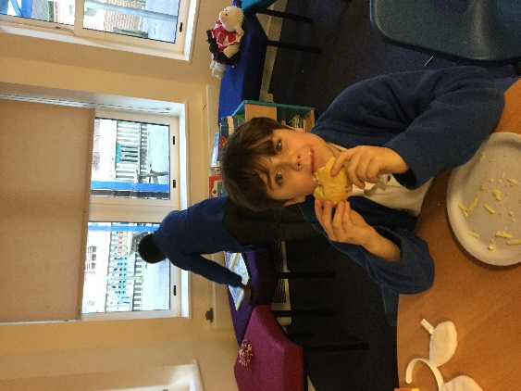

Making our own bread and then eating it with

our favourite fillings.

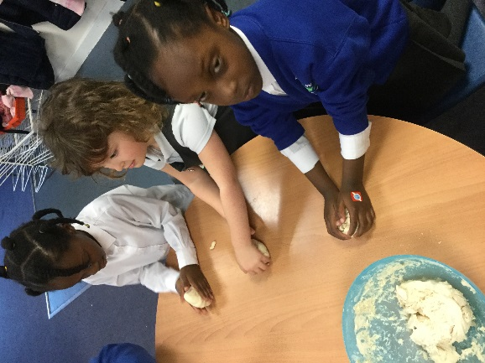

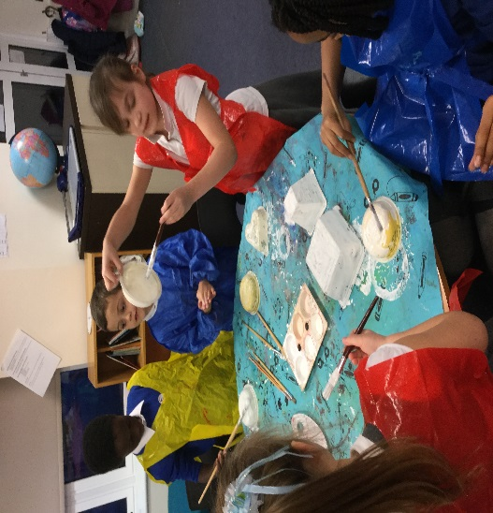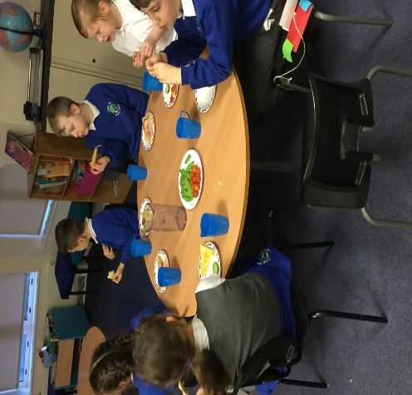

Painting our junk modelling.

Enjoying snacks together.