Term 1

After School Newsletter

2019

We have all settled back into After School Club since the summer holidays. We would like to give a very big welcome to all of our new members.

Here’s what our children had to say.

“I like creating things” – Alice Year 3.

“We get to make new friends” – James Year 5.

“I like the cheese” – Aron Year 1

What After School Club is all about.

In After School Club we provide a safe and fun environment for your children at school when you cannot collect them at the end of the school day. We do a variety of fun activities, games and even offer a snack for your children to enjoy whilst they are here.

Opening times.

After School Club is open every day from 3:15 until 5:30. If you are interested please book at the office. Miss Mayley, Mrs Morris and Miss Stokes look forward to any new members.

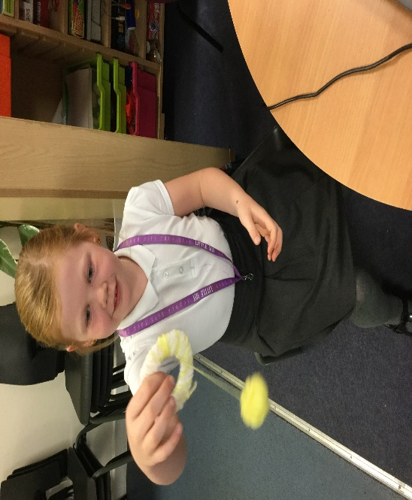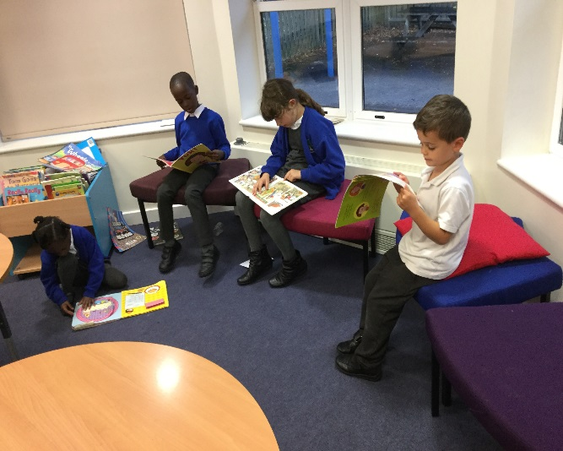

Making Pom Poms.

Delicious pizza pittas.

Enjoying books together.

Our lego creations

Here’s some of the activities we have done this term.

Making flapjacks 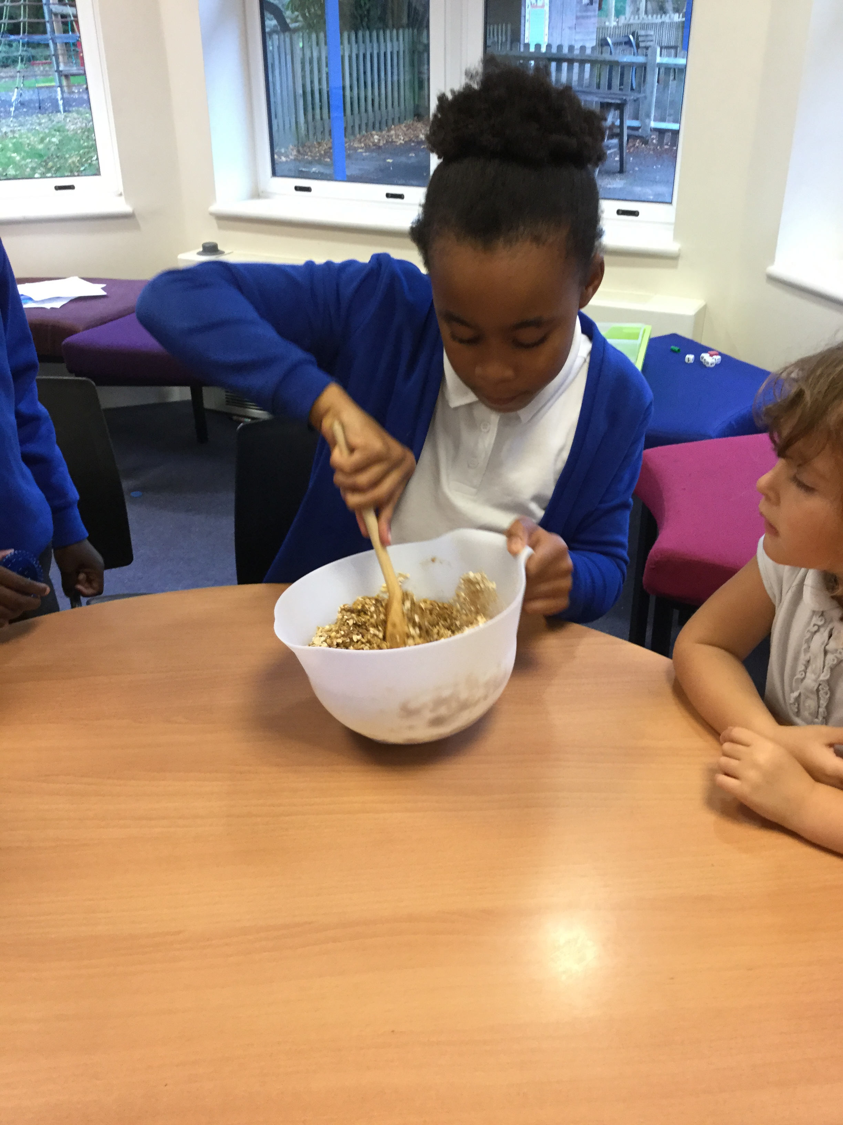apjacks

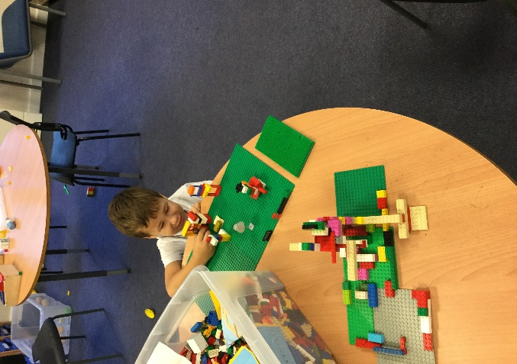

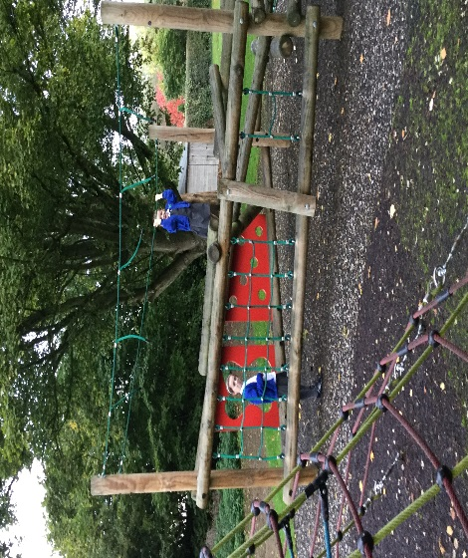

Playing on the outdoor equiptment.

