Can you find all of the inventors listed below in the wordsearch? They can be forwards, backwards, horizontal, vertical or diagonal.

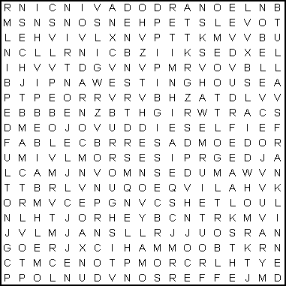
ARCHIMEDES, BELL, BENDIX, BENZ, BUNSEN, BURROUGHS,
CARTWRIGHT, COLT, CROMPTON, DAIMLER, DE SEVERSKY,
DIESEL, DUNLOP, EDISON, FORD, FRANKLIN, FULTON,
JEFFERSON, LEONARDO DA VINCI, MARCONI, MORSE, NOBEL,
PULLMAN, SINGER, STEPHENSON, TULL, WATT, WESTINGHOUSE

