KS1 reading guide for parents

How to support your child with their reading

Why read at home?
Every parents has a vital role to play in helping their child to read.
It is essential that a partnership between home and school is established to support your child in their development of reading.
Research has found that daily reading has a huge impact on a child’s development.
How to Help – A Summary
Your child needs support to develop both word reading strategies and understanding of the text.
Ways to help word reading
- Can your child use a range of strategies?
- Are they using phonics to sound out unfamiliar words?
- Does your child recognise high frequency or key words on sight?
- Does your child use the context of the text or picture clues to help them?
Understanding
- Can your child answer simple questions about the text?
- Can they retell the story in their own words?
- Can they say what they like and dislike about the text or relate it to their own experiences?
- Can they talk about characters and their feelings?

Talk about pictures
Try to get your child to tell you what they see.
Ask them if the picture helps them to see what will happen next.
Get them to name the characters and objects they can see.
Encourage them to say the words in the text and what they mean.
Ask questions
Who? What? Where? When? Why? How? What can you see in the water? What are the people doing? How do you think the people feel? Why do you think they are happy? Have you ever been in a race?

Reading your child’s school book with them
- At the front of your RWI books that they are bringing home are a list of word. These words will contain their taught phonemes (sounds) and also some tricky words (words that don’t always sound how they are spelt). Go through these words first. You can also practise those tricky words from the flashcards sent home. As then move on past RWI books, continue to practise the tricky word flashcards at home and have more of a focus on spelling them.

2. Have a look at the book together. Discuss what they can see on the front cover and what the picture shows.
  - What is the title? Make predictions about the story.
  - Have you read any of the book, if so what has happened so far?

3. Word books
If the child is reading a word book get them to put their finger under each sound and read each word. Sound out any regular words e.g. c-a-t and then blend the sounds together to make the word ‘cat’.
If the child is struggling to blend and read the word, you can sound it out back to them and help them to hear the word.
Pause… prompt… praise
- Pause – give your child a few seconds to correct themselves, or make an attempt to read a word
- Prompt – if the word is not read correctly, or they are struggling with a word, give them some prompts. For example, use the picture clue, look ahead, think about what just happened, break the word up together or give the word to them.
- Praise – be positive and celebrate your child’s successes.
Try not to say no! Try saying:
  - Have another look…
  - Almost there…
  - Are you sure

There will be words that can’t be read using phonics (e.g. go, no) and we teach these as ‘tricky’ words or ‘sight’ words. Help the child to spot these and recognise that they are ‘tricky’ words and not to be sounded out.
Once the child is confident with segmenting and blending words they will not need to sound each word out and their reading will become more fluent. They will then only rely on phonics to decode new, unfamiliar words.
At the end of each page talk about what happened, the meaning of any new words and ensure the child understands what they have read. Some questions you might ask:
  - What is the story about?
  - What has happened so far?
  - What might happen next? Why do you think that?
  - What sort of character is…? Who is your favourite character?
  - How is this character feeling? How do you know?
  - Did you like this book? Why?
  - What was your favourite part of the book?
  - Why did the character…?
4. When you have finished reading, write a quick comment in their reading record. This should be a positive, constructive comment about the child’s reading. For example ‘Fantastic reading today! You used phonics to sound out new words. Keep working on your tricky words.’
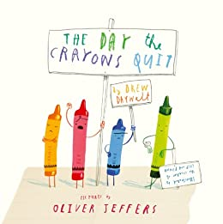
Additional Top Tips
Model a love of reading to your child in a range of contexts. Show enthusiasm for reading and for books. You can also show a love for reading through story CDs and audiobooks. This gives them a broader range to access and enjoy reading.
Keep old newspapers, magazines and leaflets and let children cut the letters out. Can they spell their name or make words and sentences with these letters?
Visit the library and find new books together. Get excited about discovering new books.
Practise the sounds of language – read books with rhymes. Talk about the sounds at the beginning of words. Play I Spy and other games. Teach your child rhymes, short poems and songs.
Find every opportunity you can to draw attention to reading in the world around your child. Look at labels in shops, signs when driving or at the park. Make purposeful links with reading.
Read stories to your child and share your favourite books with them.
Make time for reading together – not just at bedtime or in the car. Carve out time for some valuable reading experiences.
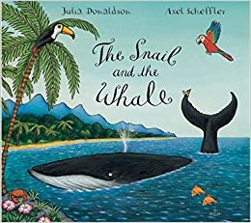
Discuss the vocabulary in the books and check if they understand the meaning. If not, go over the meaning of new words to support their development.
End the day with a bedtime story

