Still Life
Drawing from observation is a skill that any keen artist should spend time developing. The best way to do this is to physically put different objects (leaves, flowers, vases, fruits, vegetables, books… anything!) on the table in front of you and challenge yourself to draw what you see. You can also use high-quality photos, like 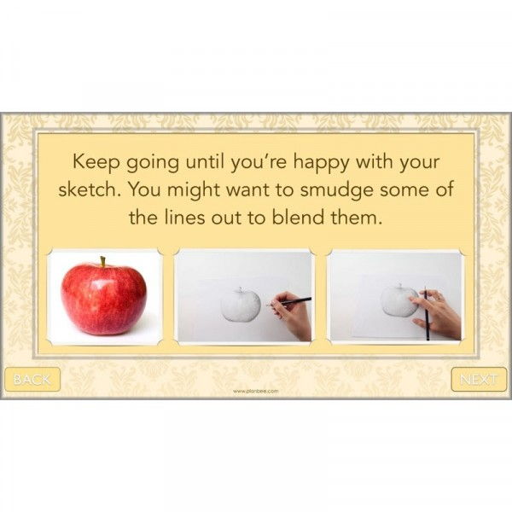Another good challenge for still life observational art is to choose from, e.g. reds and yellows. Can you paint an apple using just these colours? How will you create the shading? What effect do the colours give this painting? for example 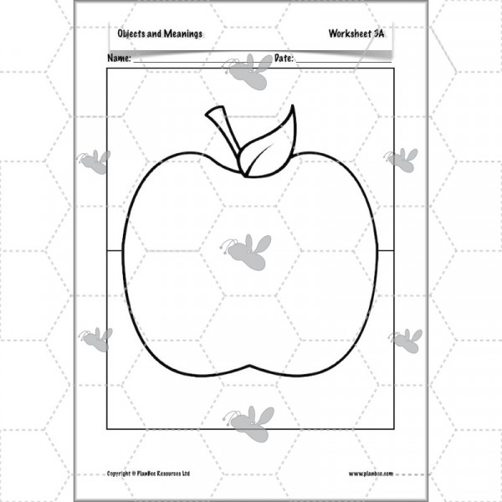
We would like you to choose something from home to draw in detail. You may want to use colours or just a pencil and shade your picture. We cannot wait to see your results.

