Literacy Learning
Wednesday 13th May, 2020
Literacy (Fantastic Mr Fox)
Over the next three days we will be reading parts of a classic book by Roald Dahl called ‘Fantastic Mr Fox.’ Each day, we will reading a chapter of the book and then completing an activity related to the chapter.

I want to give you the option of reading the text or listening to it. Therefore the text from the book has been uploaded separately on the class webpage for you to read on your own or with an adult. Alternatively, you could listen to the relevant chapter using the following link: https://www.youtube.com/watch?v=nJofxwa5bMo
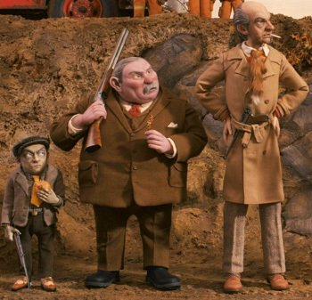
Activity 1
Read Chapter 1: The Three Farmers.

Activity 2
In this chapter, we are introduced to the three farmers. Roald Dahl has used two ways of describing the characters.
- Expanded noun phrases, e.g. Bunce was a kind of pot-bellied dwarf.
- Similes, e.g. Bean was thin as a pencil.

Draw pictures of the members of your immediate family. You may use the ‘Family Album’ worksheet. Then write a description of each member of the family using expanded noun phrases and similes. Try and be kind to your siblings!

Spellings

