Literacy Learning
Friday 15th May, 2020
THERE IS NO SPELLING ACTIVITY TODAY AS YOU HAVE AN EXTENDED PIECE OF WRITING TO DO.
Literacy (Fantastic Mr Fox)
We are going to continue to read ‘Fantastic Mr Fox’ and then complete an activity related to it.

You have the option of reading the text (it has been uploaded on the class webpage) or to listen to the relevant chapter using the following link: https://www.youtube.com/watch?v=nJofxwa5bMo

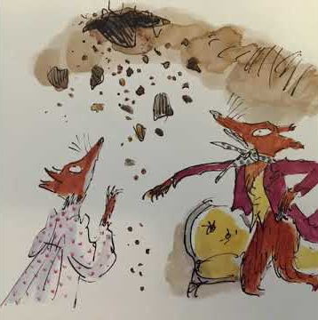
Activity 1
Read Chapter 4: The Terrible Shovels and Chapter 5: The Terrible Tractors.

Activity 2
All that digging from the shovels and tractors would have made an awful lot of noise in the woods! Imagine you are one of the other animals in the woods. You could be a badger, a mouse, an owl or any other woodland animal.
What were you doing when you heard that awful racquet? Were you asleep or awake? How did it make you feel? What did you think it was? What did you do? Do you blame Mr Fox and his family or do you think they are victims?
Write a diary entry as another animal in the woods. Describe what you did when you heard the noise and how it made you feel. Also include description of what you think of those nasty farmers Boggis, Bunce and Bean.

