Topic Lesson 19.05.2020
How can we attract more insects, birds and other wildlife to our school to increase our wildlife and help other species?
The National Trust has lots of ideas here: https://www.nationaltrust.org.uk/features/nine-ways-to-build-a-wildlife-friendly-garden
You can also watch a video of some of these animals that might visit your garden: https://www.bbc.co.uk/bitesize/clips/z49g9j6
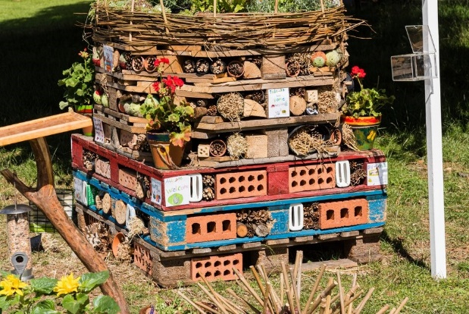  https://www.youtube.com/watch?v=E2aIEQjt9zE  Making a bug hotel | 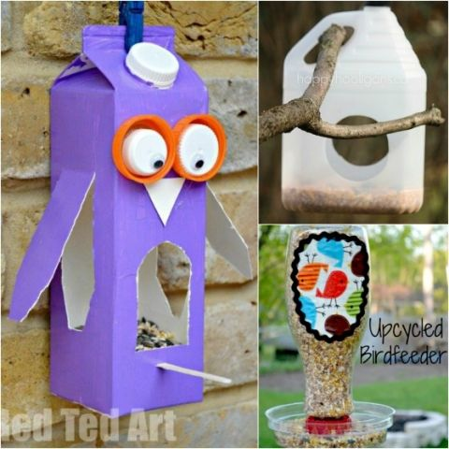  https://www.youtube.com/watch?v=sKIyeeCBL-w  Making bird feeders
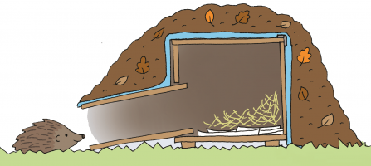
Making a hedgehog home
https://www.youtube.com/watch?v=mNnbvPdVYRU

Could you make one of these in your home using any recycling or junk modelling equipment that you have? Please send us some pictures of your creations!

