Topic 22.05.2020
This term you have learnt lots about plants, insects and wildlife on planet Earth. We would like you to create something to show off everything you have learned in topic. This can be in the form of a poster, a PowerPoint, a video or any other way you can think of!
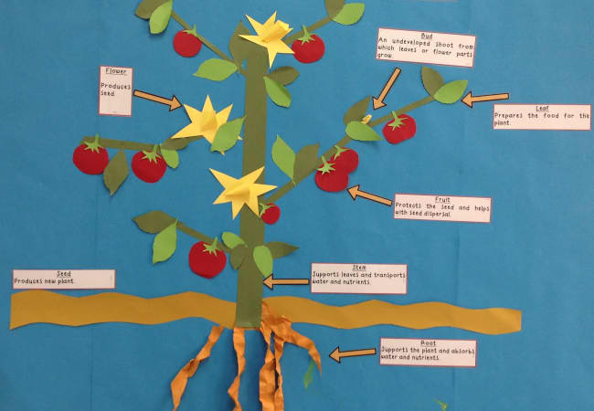
You can use the half-term to complete this learning it doesn’t all have to be done in one day.
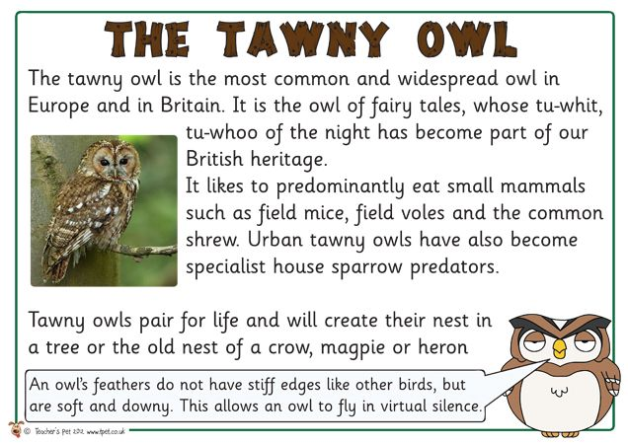
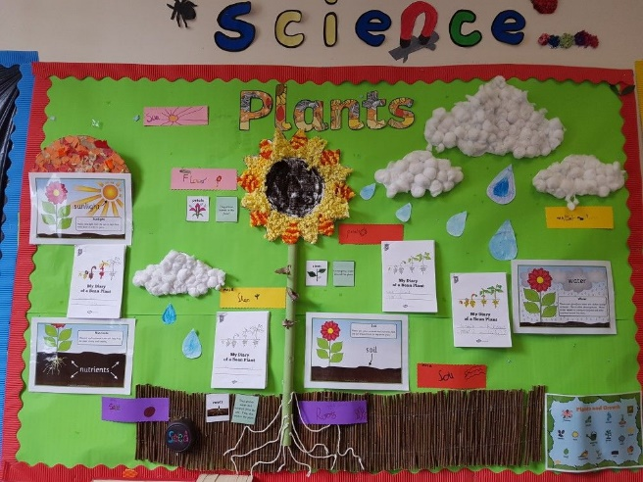
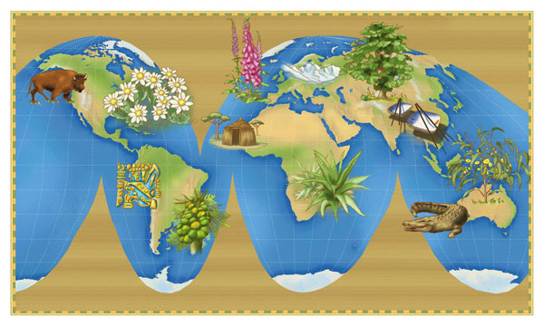

There is also a quiz to complete on today’s blog post. Let us know how you get on!

