Literacy Learning
Friday 22nd May, 2020
Literacy (Fantastic Mr Fox)
We are going to continue to read ‘Fantastic Mr Fox’ and will then complete an activity related to it.

You have the option of reading the text (it has been uploaded on the class webpage) or to listen to the relevant chapter using the following link: https://www.youtube.com/watch?v=nJofxwa5bMo

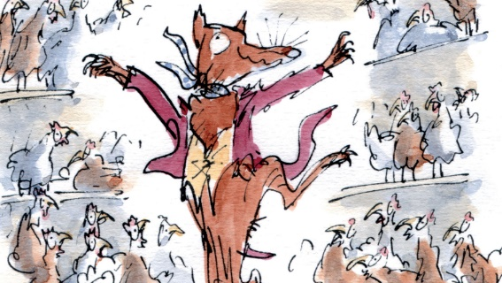
Activity 1
Read Chapter 11: A Surprise for Mrs Fox and Chapter 12: Badger

Activity 2
How do you think the story is going to end? What do you think is Mr Fox’s new plan? Is he going to get any help from other animals? Do you think Mr Fox will win over the Farmers or the Farmers will eventually catch Mr Fox?
Predict what you think is going to happen next and write the ending of the story.
It is half-term from the week beginning the 25th of May. If you want to you can finish reading the story. There are 6 more chapters to go. There is also a film version available on Amazon Prime.

