Text Conversation Between Characters

Little Red Riding Hood: Oh Grandma! I never realised your eyes were so big! 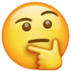
Big Bad Wolf: They are so I can see you better, my love. 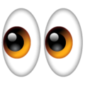
Little Red Riding Hood: Grandma, have your ears always been this big?
Big Bad Wolf: It is so I can hear you better, dear.
Little Red Riding Hood: Oh Grandma. What great teeth you have?
Big Bad Wolf: All the better to eat you with!
Little Red Riding Hood:

