Term 5 Challenge – Throw Clap Catch

This is a test of rhythm, speed, concentration and coordination in a set time.

The challenge will be differentiated between Key stages by a varied amount of time to perform the challenge in.
- EYFS – 20 seconds
- Key stage 1 – 30 seconds
- Key stage 2 – 45 seconds.

Throw Clap Catch – Children will throw either a beanbag or tennis ball into the air and clap before catching it again. They must complete 1 clap before catching the ball or beanbag again. Children will score 1 point for every time they catch it after a clap, if the beanbag/ball is dropped that point is not counted and the next successful catch will continue the score.

EYFS and KS1 – Children may use a beanbag for this challenge and complete 1 clap between each throw and clap

KS2 – Children will use a tennis ball for this challenge and complete 1 clap between each throw and catch.
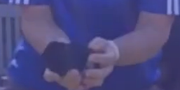
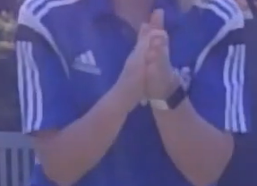

THROW CLAP CATCH

Rules:
- The participant must complete as many throw clap catches as possible in the time limit.
- Each time the beanbag/ball is caught after a clap counts as 1 point.
- If the beanbag/ball is dropped that point is not counted. Children will continue scoring from the next throw clap catch

Tips:
- Two judges are recommended one for timing and one for counting. If not enough stop watches then class teacher can time for everyone at once.
- Keep the counter consistent so this remains a fair test.
- Ensure participants in a good space to avoid being hit by any balls.
- During the session try not to have everyone waiting around for their turn.
- Encourage children to practice on their own to attempt to improve their score.
- Repeat the personal challenge at the end of term and record the results to see if there has been an increase in their score.
Good Luck Everyone!

