Congratulations to

Park way

third Place

in the Kent School Games

Infant Agility Competition

May 2021

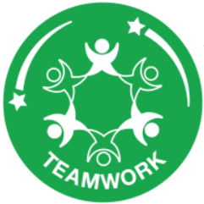

Senior School Games Organiser

