**Term 6 Challenge – Runner**

**This is a test of speed, strength, agility and motivation**

The challenge will be differentiated between Key stages by a varied distance and amount of time to perform the challenge in.

* **EYFS – 30 seconds**
* **Key stage 1 – 40 seconds**
* **Key stage 2 – 50 seconds**

**Shuttle runs –** Children will have to run between 2 sets of cones – 5M for EYFS and Ks1 and 10M for Ks2. Children will earn 1 point every time they run to the opposite and place 1 foot over the line. If children are half way through a run when the time ends they will not score a point for that run.

**EYFS and KS1** – 2 sets of cones should be placed 5metres apart, children start behind the line and run to the other end placing one foot over the line before turning and running back to the other side. They continue to do this until the time runs out.

**KS2** – 2 sets of cones should be placed 10metres apart, children start behind the line and run to the other end placing one foot over the line before turning and running back to the other side. They continue to do this until the time runs out.

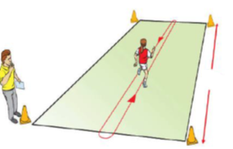

5M

**Rules:**

* Children begin from a standing position behind the start line.
* On the whistle the athlete runs 5 or 10 meters to the set of cones opposite.
* Children must place one foot over the return line before turning and running in the opposite direction.
* Children should work in pairs – one child is running and the other is counting how many runs they complete.

**Tips:**

* Two judges are recommended one for timing and one for counting. If not enough stop watches then class teacher can time for everyone at once.
* Keep the counter consistent so this remains a fair test.
* Ensure enough space for all participants – set up more than 1 running course.
* During the session try not to have everyone waiting around for their turn.
* Encourage children to practice on their own to attempt to improve their score.
* Repeat the personal challenge at the end of term and record the results to see if there has been an increase in their score.

**Good Luck Everyone!**