Term 2 Challenge – Pass Around

This is a test of speed, rhythm and coordination in a set time.

The challenge will be differentiated between year groups.
- EYFS will be using a beanbag
- KS1 will be using a soft medium or large ball
- KS2 will be using a basketball.

All year groups will complete the challenge for 30 seconds.

Pass Around – Children will use their designated piece of equipment and attempt to pass it around their waist as many times as possible in 30 seconds. The equipment must be passed from 1 hand to another around the waist and not rolled around the waist.
Children will get 1 point for every full rotation of the waist if the ball/beanbag is dropped that point does not count but children should carry on and continue to score.

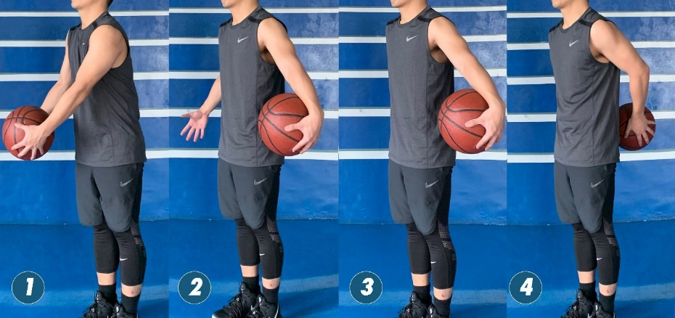

Count how many passes are performed in the time limit.

Rules:
- Starting on the whistle the participant must complete as many passes around their waist as possible
- If the ball is dropped that point does not count, children should pick it up and carry on.
- The ball/beanbag must be passed around the waist, not rolled around the body.
- The time stops on the whistle.

Tips:
- Two judges are recommended one for timing and one for counting.
- Keep the counter consistent so this remains a fair test.
- Ensure participants are wearing suitable, safe footwear.
- During the session try not to have everyone waiting around for their turn.
- Encourage children to practice on their own.

Results should be recorded on the attached results document and returned by
Thursday 9th December 2021.

Good Luck Everyone!

