Easter Holidays Home Learning
We have had an amazing term back at school and we have come so far with our learning and progress. To ensure that we keep up our learning and to help us remember what we have learned, please complete the activities in the grid below.
You can complete them in any order, multiple activities a day or spread over the two week break. (Activities highlighted in blue should be completed daily to support your child’s continued progress)
Access your Spelling Shed account and practice your tricky words – how many games can you play?  (Please contact us on our Team pages if you need your details) | If you don’t already know, learn to tie your shoe laces. | Bake something delicious with your family! Take pictures of your creation! | Help by setting the table or washing up the dishes
Write a recount about something exciting you have done during your holiday.  Please remember:  - Handwriting  - Punctuation  - Conjunctions | Read with an adult every day. This could be a book at bedtime, helping reading a recipe as you bake something or even road signs if you go on a walk! | Year 2 – practice your 2,3,5 and 10 times tables.  Year 1 – practice your number bonds to 10 and 20.  (all can be done via hit the button on google) | Use your Easter egg boxes to create something interesting!
Get outside and get creative!  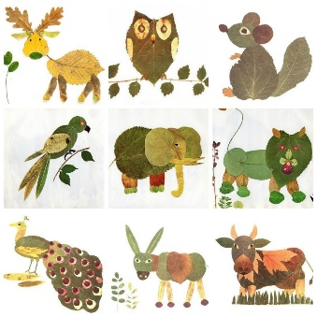  Make your very own animal using leaves and natural resources | Please practice your handwriting following the school handwriting policy which is cursive. We have attached a document that shows each letter and how it formed to help you. | Watch your favourite film. Draw a picture of your favourite part of the film and tell us why it’s your favourite! | Access your Oxford Owl account (please see your Teams for your login details)  and read the book that has been assigned to you from RWI.

