Lower KS2 reading guide for parents

How to support your child with their reading

Why read at home?
Every parent has an important role to play in helping their child to read. A partnership between home and school is essential.
Research shows that daily reading has a huge impact on children’s development.
Even though your child may read fluently by Year 3 and 4, it is still essential to listen to children read aloud and ask probing questions to develop understanding.
How to Help – A Summary
Your child needs support to develop both word reading strategies and understanding of the text.
Word Reading Strategies
● Can they use a range of strategies? Recognising whole words/using their phonics to break words down/using the context of the sentence or clues in the pictures.
Reading Aloud
● Does your child use their voice to make their reading interesting?
● Can your child use expression?
● does your child take into account sentence structure?
● does your child respond to punctuation? For example looking for exclamation marks, speech marks, italics etc. to give clues.
Retrieval
● Can your child find information in the text to answer simple questions about who, where, when, what? Once your child is confident with these basic skills, they will need support to develop a more complex understanding of a text.

Interpretation
● Can your child put themselves in the character’s shoes?
● Answer questions such as: how do you think they feel? Why do you think/explain/how do we know? What might happen next? How is it set out? What type of text is it? (instruction/letter/newspaper/fairy story)
● If it is a non-fiction book, can your child explain how to use contents/index etc?
● Can your child discuss other stories they know with a similar setting or theme? How does this compare to other books by the same author?

Author’s choices and impact
● Can your child discuss the choices made by the author and the impact of these on the reader?
● For example, answering questions such as: what words did the author use to create excitement or a sad feeling? Have they used similes or alliteration? Discuss adjectives or adverbs used and different types of sentences. How has the author set out or organised the text?
● Can your child consider viewpoint?
● For example, answering questions such as: Why did the author choose this setting? What does the author want you to believe? Do they want to persuade you to do something? What is the author’s opinion on the topic? What are your opinions about a book? Say what you like or dislike about a book and give reasons why.

Reading your child’s school book with them
● Discuss the book’s front cover and blurb with your child. What do they predict the story is about? Can they make links between the front cover and the storyline?
● If your child has read some of their book without you, can they summarise what they’ve read? Can they identify the key plot points they remember?
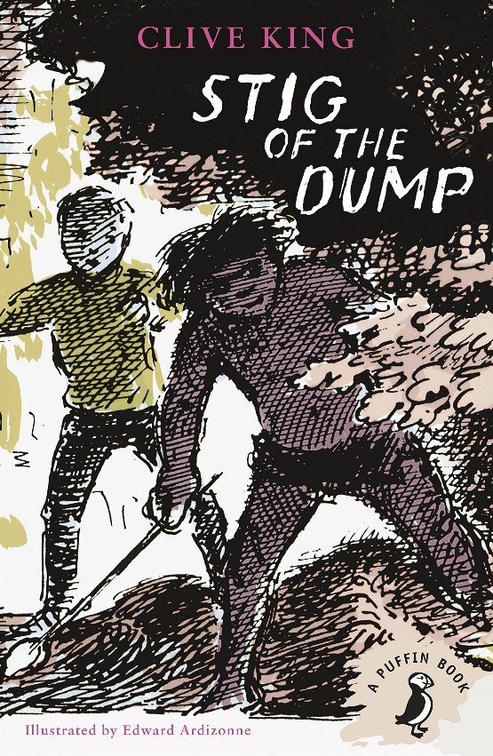
● Can your child answer simple retrieval questions about what they read independently? If not, perhaps they need to re-read this section.
● Listen to your child read a section of their book. Discuss their understanding of the story so far. If there is new vocabulary, discuss the meaning of new words or phrases to expand their vocabulary.
● Remember to sign your child’s reading record. Leave positive comments about their reading, for example ‘great reading tonight, you used great expression with the characters and remember to sound out longer, unfamiliar words’. This helps them to see what they need to focus on and gives additional information to their class teacher when planning support for your young reader.

Additional Top Tips
● Model a love of reading to your child in a range of contexts. Show enthusiasm for reading and for books.
● Keep tabs on the types of books your child is reading. Try to challenge them to read a range of text types.
● Use our recommended reading suggestions to help your child choose age appropriate, challenging books.
● Visit the library and find new books together. Get excited about discovering new books.
● Write a book review together.
● Use non-fiction to engage children in purposeful reading. For example, follow instructions to make dinner.
● End the day with a bedtime story.

Additional Top Tips
Model a love of reading to your child in a range of contexts. Show enthusiasm for reading and for books.
Keep old newspapers, magazines and leaflets and let children cut the letters out. Can they spell their name or make words and sentences with these letters?
Visit the library and find new books together. Get excited about discovering new books.
Practise the sounds of language – read books with rhymes. Talk about the sounds at the beginning of words. Play I Spy and other games. Teach your child rhymes, short poems and songs.
Find every opportunity you can to draw attention to reading in the world around your child. Look at labels in shops, signs when driving or at the park. Make purposeful links with reading.
Read stories to your child and share your favourite books with them.
Make time for reading together – not just at bedtime or in the car. Carve out time for some valuable reading experiences.
Discuss the vocabulary in the books and check if they understand the meaning. If not, go over the meaning of new words to support their development.
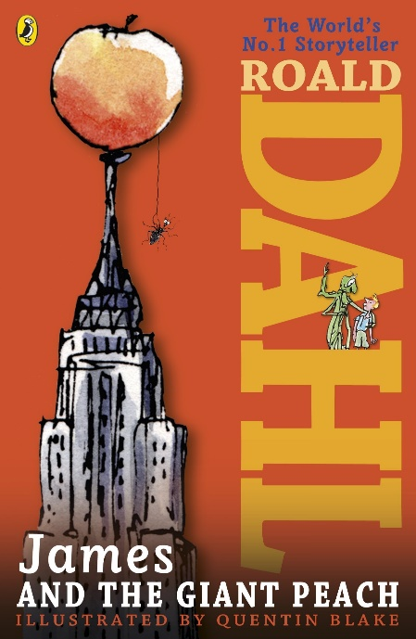
End the day with a bedtime story

