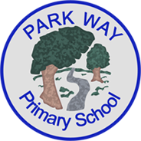Tapestry Childhood Education Platform Consent Form

Dear Parents and Carers,

This letter is to inform you about our use of Tapestry Childhood Education Platform.

Tapestry is award-winning software with tools to help educators work in partnership with families, document children's learning and development, and develop a child-centred approach to planning and assessment. It is used in thousands of settings and schools across the UK and worldwide.

Each child will have their own online learning journal on Tapestry. This journal will enable us to follow your child's learning and development, and to plan experiences to help them to make progress. Through the journal we will share 'observations' with you, which can be words, pictures and videos about your child's time here. You will also be able to use Tapestry to add pictures and videos of learning and experiences that happen at home. These will help us to get to know your child better - getting to know each child is at the heart of our good practice.

At the end of your child’s time with us in Reception class, you can download a PDF copy of your child’s journal as a keepsake. You are also able to export this yourself at any point. The journal will include their observations and pictures. You’ll be able to download this from your account.

As this is an online profile, we will need your permission to create an account for your child and yourself. Please rest assured that the information about your child and their learning is secure and is only accessed by the members of staff and yourselves. Any personal details about your child are confidential and will not be disclosed.

To comply with the Data Protection Act 2018, we also need your permission before we can photograph or make any recordings of your child.

Tapestry acts as data processor, and securely stores all the data we input to our account on their servers. As processors, they are bound by strict data protection regulations. If you want to find out more information about how Tapestry keeps our data safe and secure, you just need to go to [the Tapestry Security page](https://tapestry.info/security/).

Once you have returned this consent form, you will receive an email with an activation link to activate your Tapestry profile. This email can sometimes end up in the spam folder. You will need to choose a password, which you will use to log in to both the Tapestry app and the desktop version. You’ll also be able to set up a 4-digit PIN to quickly log in to the app. Your profile will be linked to your child’s, so please refrain from sharing your details with other users. We can link as many adults as needed to every child, so please let us know if you’d like additional family members added to Tapestry.

Please complete the attached form and return to your class teacher.

If you require any more information regarding Tapestry and its features, you can visit Tapestry’s Parents and Carers area by scanning the QR code below. If you experience difficulties at any time accessing your child’s journal, please speak to Mrs Trulser, EYFS Lead.

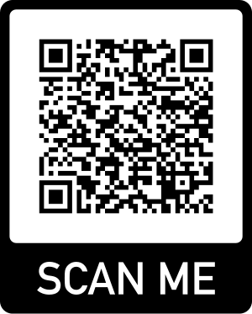

Thank you for your support,

Mrs Trusler

EYFS Lead.

Parental Consent Form – Tapestry

Child’s name: ___________________________________________

Class: ___________________________________________

Please tick all relevant boxes to provide consent to the use of Tapestry.

We/I:

|  |  |
| --- | --- |
| Give permission to **setting/business/school name** to store my personal data including but not limited to my child’s name, family names and contact details including my email addresses, home address and contact numbers. Please note that without this information full functionality of Tapestry is limited. |  |
| Give permission to **setting/business/school name** to create a Tapestry profile for my child and store their personal data including but not limited to their date of birth, full name and any benefits they may receive. Please note that without this information full functionality of Tapestry is limited. |  |
| Give permission for our child’s image either in a video or as a photograph to be uploaded as part of an observation for their online learning journal. |  |
| Give permission for our child’s image to be included in newsletters and displays. |  |
| Give permission for our child’s image to be used in our publicity, prospectus or on the website. |  |
| Give permission for our child’s image to occasionally appear in other children’s online learning journals, meaning other families will be able to see my child’s picture, and my child might feature in other children’s PDF journals – which can be exported by parents - and printed books. |  |
| Agree to protect images of other children who may occasionally appear in any photographs or videos contained in our child’s online learning journal. Failure to do so will revoke access to Tapestry. |  |
| Agree to not publish images of my child or other children and/or staff members on any social media sites, including but not limited to Instagram or Facebook. Failure to do so will revoke access to Tapestry. |  |
| Agree to refrain from sharing our personal login details to others keeping our child’s account private to ourselves. |  |
| **Agree for my child’s regular schedule to be managed from Tapestry and for me to be invoiced through Tapestry.** |  |

Parent or Carer 1

Name (in print): ___________________________________________

Email address*: ___________________________________________

Relationship to child: ______________________________________

Parental responsibility: Yes/No

Signature: ________________________________________________

Date: ____________________________________________________

*To be used for your Tapestry profile.

Parent or Carer 2

Name (in print): ___________________________________________

Email address*: ___________________________________________

Relationship to child: ______________________________________

Parental responsibility: Yes/No

Signature: ________________________________________________

Date: ____________________________________________________

*To be used for your Tapestry profile.

***Please return this to the school office with your welcome pack****.*